Clean Sky 2 Programme: Overview, Structure and Contributors

Clean Sky 2 overview
Clean Sky 2 builds on the work of Clean Sky. Close alignment between the two ensures a seamless transition and anchors the gains that can be reached in impacts and societal benefit. Based on the technology readiness level (TRL) demonstrated at the end of Clean Sky, several technologies will be ready for potential development and deployment. Others will need to be matured further within a research environment, and will require a higher level of system integration and further validation under Clean Sky 2. More importantly, given the extremely long development and product life-cycles in aeronautics, and the levels of investment and financial risk going well beyond the private sector’s autonomous capability, the long-term stability in research agenda and funding through an instrument such as CS2 is essential in addressing long-term goals as set out in the renewed SRIA where it has been patently stated that evolutionary technology development and incremental performance improvements will no longer suffice. The PPP approach creates the best conditions to give the required confidence to market players to invest in breakthrough innovation. The inclusive approach coupled with the active pursuit of synergies will also allow the CS2 Programme to exploit synergies between its technologies and those matured outside with potential complementarity. Innovations from CS2 will drive major advances in the next generation of aircraft by mastering the technologies and the risks, in time to meet the market window to replace the current fleet.
High Level Objectives for Clean Sky 2
The Clean Sky 2 Programme builds on its predecessor, but will also drive towards more ambitious objectives and extend its reach [including longer-term and lower-TRL actions] in order to:
- Accelerate the progress towards the ACARE SRIA goals for 2020-2050;
- Enable a technological leap in the face of emerging competitors;
- Justify the early replacement of aircraft that have yet to enter service and accelerate the adoption of new technology into the global fleet.

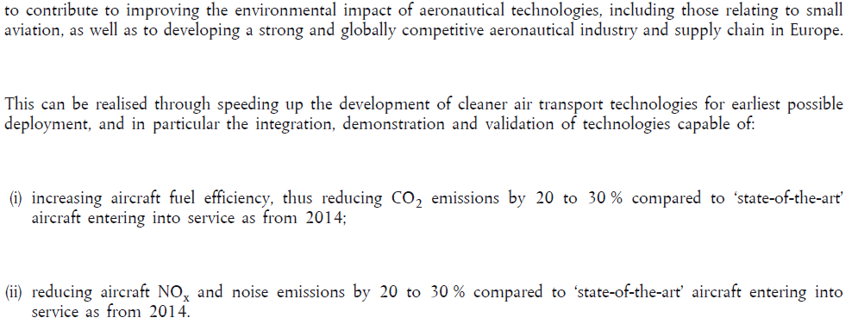
High Level Objectives for Clean Sky 2 as set out in the Regulation [see also Figure 2]

The Programme aims to accelerate the introduction of new technology in the 2025-2035 timeframe. By 2050, 75% of the world’s fleet now in service (or on order) will be replaced by aircraft that can deploy Clean Sky 2 technologies. Based on the same methodology as applied in the Clean Sky economic case in 2007 the market opportunity related to these programmes is estimated at ~€2000 billion. The direct economic benefit is estimated at ~€350-€400 billion and the associated spill-over is of the order of €400 billion. These figures are additive with respect to the Economic Value Added expected from Clean Sky. As a result of the higher growth now forecast, the environmental case for continuing the Clean Sky with the CS2 Programme is even more compelling. CS2 technologies will bring a potential saving of 4 billion tonnes of CO₂ through Clean Sky 2 from roughly 2025 through to 2050 in addition to approximately 3 billion tonnes achievable as a consequence of Clean Sky.
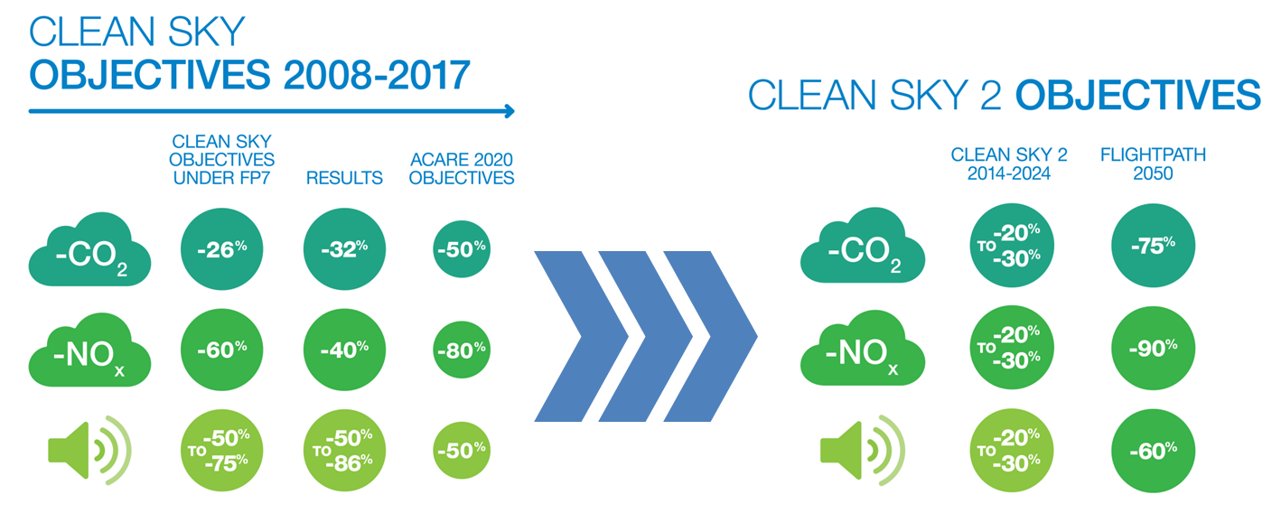
Figure 2: Transition from Clean Sky 1 to Clean Sky 2

Clean Sky 2 overall programme structure
The set-up of the Clean Sky 2 Programme is based on the notion of building on and extending the successful formula trialled in the Clean Sky Programme under FP7. As such Clean Sky 2 continues to use the Integrated Technology Demonstrators (ITDs) mechanism. The ITD instrument’s objective-driven agenda to support real market requirements providing the necessary flexibility is well-suited to the needs of the major integrator companies. The new Programme also focuses on reinforcing interactions between demonstrations of improved systems for a better integration into viable full vehicle architectures. The Clean Sky 2 structure involves demonstrations and simulations of several systems jointly at the full vehicle level through Innovative Aircraft Demonstrator Platforms (IADPs).
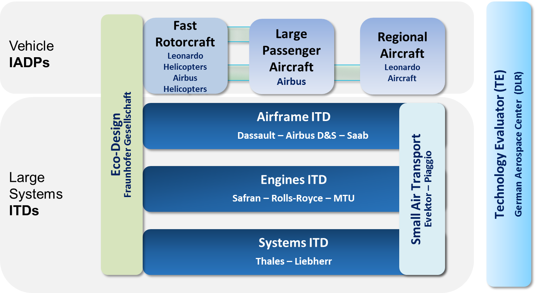
Figure 3: Clean Sky 2 Programme Logic and Set-up

Innovative Aircraft Demonstrator Platforms [IADPs] aim to carry out proof of aircraft systems, design and functions on fully representative innovative aircraft configurations in an integrated environment and close to real operational conditions. To simulate and test the interaction and impact of the various systems in the different aircraft types, vehicle demonstration platforms are covering passenger aircraft, regional aircraft and rotorcraft. The choice of demonstration platforms is geared to the most promising and appropriate market opportunities to ensure the best and most rapid exploitation of the results of Clean Sky 2. The IADP approach can uniquely provide: Three IADPs are defined in the CS2 Programme:

- Large Passenger Aircraft [LPA] covering large commercial aircraft applications for short/medium and long range air transport needs;
- Regional Aircraft [REG] focusing on the next generation of approx. 90-seat capacity regional turboprop powered aircraft enabling high efficiency/reliability regional connections;
- Fast Rotorcraft [FRC] aiming at new configurations bridging the gap between conventional helicopters and utility / commuter fixed wing aircraft: both in speed and range/productivity.

In addition to the complex vehicle configurations, Integrated Technology Demonstrators (ITDs) will accommodate the main relevant technology streams for all air vehicle applications. They allow the maturing of verified and validated technologies from their basic levels to the integration of entire functional systems. They have the ability to cover quite a wide range of technology readiness levels. Each of the three ITDs orientates a set of technology developments that will be brought from component level maturity up to the demonstration of overall performance at systems level to support the innovative flight vehicle configurations:

- Airframe ITD [AIR] comprising topics affecting the global vehicle-level design;
- Engines ITD [ENG] for all propulsion and power plant solutions;
- Systems ITD [SYS] comprising on-board systems, equipment and flight management.

The Transverse Activities [TAs] enable important synergies to be realised where common challenges exist across IADPs and/or ITDs; or where co-ordination across the IADPs and ITDs allows a cogent and coherent approach to common technical challenges. TAs do not form a separate IADP or ITD in themselves, but coordinate and synergise technical activity that resides as an integral part of the other IADPs and ITDs.

- Eco-Design TA [ECO]: Addressing materials, processes and resources impact considering the life cycle optimisation of technologies, components and vehicles - their design, manufacturing, operation, maintenance and disposal; and addressing the ever-increasing pressure to reduce harmful impacts on the Earth’s resources and the impact related to scarce elements and resources;
- Small Air Transport TA [SAT]: airframe, engines and systems technologies for small aircraft, extracting synergies where feasible with the other segments;
- The Technology Evaluator will enable an independent Technology and Socio-Economic Impact Evaluation which is an essential task within the CS2JU. Environmental Impact Assessments currently focused on noise and emissions will be continued and expanded where relevant for the evaluation of the Programme’s progress. Other impacts, such as on Mobility or on Industrial Leadership of Clean Sky 2 concepts will be assessed.

